



Problem statement

A year ago in Chicago, the high incidence of crime prompted the government to take decisive action by launching an operation with top-performing police officers. Now, as a year has passed since this decision, the government seeks to evaluate the reduction in crime cases and the advantages gained from this new operation. The government has engaged you as a freelancer data analyst to analyse the changes and improvements in crime rates.  The government is seeking the following objectives from your analysis:

* If the case solving time improved
* What are the localities where the crime rate were higher
* What can be the measures that can be taken in order to further improve the crime

Objective questions

1. In analysing the provided dataset with Power BI, ensure data cleaning to address inconsistencies and missing values before further analysis.

**Method using for Cleaning the Data:**

**I** Use Power Query Editor to apply transformations to my data. The "Transform Data" option in the "Home" tab opens Power Query Editor.

**Removing Duplicates**: I use "Remove duplicates" feature to eliminate duplicate rows in my data Formula used is: Table Select Rows (#"Removed Duplicates", each [Ward] <> null and [Ward] <> "")

**Filtering:** I Applied filters to exclude or include specific rows based on certain criteria and I use the "Filter Rows" feature in the "Home" tab formula used is: = Table Select Row (#"Filtered Rows", each ([X Coordinate] <> null and [X Coordinate] <> "")), = Table. Remove Rows with Errors (#"Promoted Headers")

**Error Handling:** I Implement error-handling mechanisms to deal with null values or unexpected values in my data.

**Custom Calculations: I** Created a custom column name Month name from date column and I extract month only from that formula used is Month Name = MONTH('crimes_data_2022'[Date]

**2.Crime Type Analysis:** Assess the frequency of each crime type to identify the most prevalent crimes occurring in the area

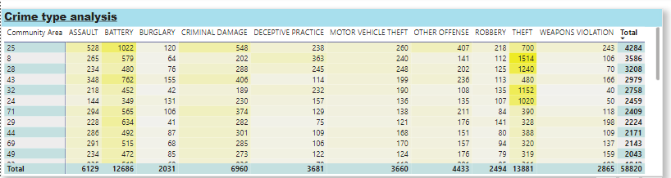

**Method Used:** I have used Matrix table in which rows are community area and columns are type after creating the table I applied filters on rows and columns and selected top values from each column. The reason is I want to identify most prevalent crimes occurred in the area.

Top 5 Areas with most criminal activity: 25,8,28,43,32

**3Arrest Rate Evaluation:** Analyse the percentage of reported incidents that have resulted in an arrest to gauge law enforcement effectiveness

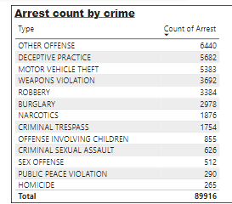

Method used: I have used donut chart here in which legends are arrest and the value are % of count type

Reported crime have resulted in an arrest: 12.42%

4. **District Crime Distribution Assessment:** Calculate the number of crimes in each district to understand how crime is distributed across the city and identify high-crime areas.

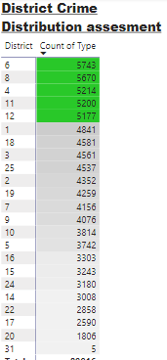

Crime distribution across a city is influenced by a complex interplay of various factors. Understanding the reasons behind the distribution of crime involves considering a combination of social, economic, environmental, and geographic factors.

Method used: I have used Matrix table in which rows are district and value is count of crime type I calculated the crimes total for all districts that is 89916

Top Districts with most criminal activities are 6,8,4,11,12

**5. Domestic Crime Proportion Analysis:** Analyse the ratio of domestic-related crimes to other types of crimes to understand the prevalence of domestic incidents

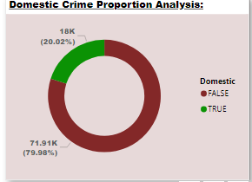

Method used: I want to find out the ratio of domestic incidents so I have used donut chart in which legends are domestic and value is count of type by percentage

Ratio of domestic related Crimes: Domestic – True, Count of type -18002(20.02%)

6. Is there any “**Location Description**” where the number of crimes higher than expectation? Come up with a table or visualization in which one can judge the frequency of crimes at each Location Description type.

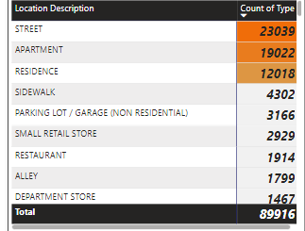

Method used: I have used matrix table here in which rows are location description and value is count of type after creating the table I sort Descending the table by count of type column now I can easily list the high values.

7. What is the average time between reporting and solving a case as per the data?

Method used: I Created a new measure named time difference and I have used aggregated function of datediff to find the time difference between date column and update on column The formula used here: Time Difference = DATEDIFF('crimes_data_2022'[Date],'crimes_data_2022'[Updated On],DAY)

As the question ask to show the average solving time I have used average function the formula used here: Average Time Differance = AVERAGE('crimes_data_2022'[Time Difference] So the average time difference is 9.03

8. In order to reward the patrol officers, find the patrol area where the crimes reported were under control.

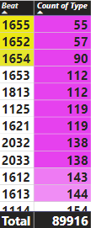

Method used: I have used Table here in which the columns are Beat and count of type and I sort ascending the table by count of type so the least number of values where comes on the top

Top 3 wards with most criminal activities are 1655,1652,1654

Subjective Questions

**1.Is there any month-wise change in crime rates? If not, what could be the mistake in that operation?**

Yes, there is a month wise change in Crime Rates

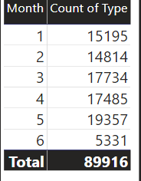

Method used: I have used stacked column chart in which x axis is Month and y axis is count of type after created the chart also created the table for better understanding there is a lot of changes in crime rates in month wise

Visualization Method used: Stacked column Chart

Location

Power bi file- sheet name –Month wise change

**2.How can we reduce the no. of crimes, and which types of crime should we focus on to achieve improvement in overall number of crimes?**

General strategies for reducing Crime rates

**Community Engagement and Policing:**

* Foster positive relationships between law enforcement and communities through community policing.
* Encourage community members to actively participate in crime prevention efforts.

1. **Prevention through Education:**
   * Invest in educational programs that address the root causes of criminal activity.
   * Implement awareness campaigns to educate the public about crime consequences.
2. **Social Services and Support:**
   * Provide accessible mental health services, substance abuse treatment, and social support.
   * Address issues such as homelessness and unemployment that contribute to criminal activities.
3. **Economic Development:**
   * Promote economic opportunities and job creation to reduce socio-economic disparities.
   * Focus on revitalizing economically disadvantaged areas.
4. **Early Intervention Programs:**
   * Implement programs that identify and support at-risk individuals, especially children and adolescents.
   * Provide counselling and mentorship to guide individuals away from criminal activities.

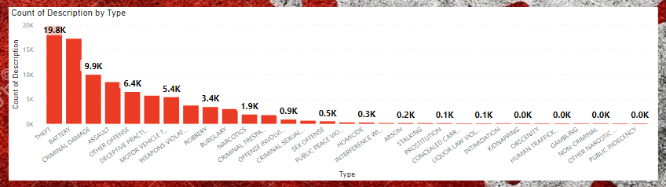

Method used: I have used stacked column chart in which x axis is type and y axis is type of description and I created a table for better understanding I sort the table ascending order by type of description

Top 3 crimes with high description

* **Theft**
* **Battery**
* **Criminal damage**

Visualization method used: Stacked column chart, Table

Location - power bi file – sheetname – crime Reduction

**3.Which localities experience higher crime rates, and what measures can we ensure to reduce these numbers?**

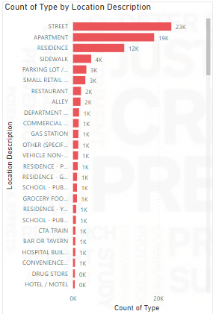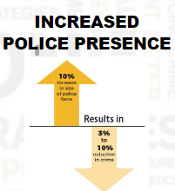

Method used: I have used stacked bar chart in which x axis is count of type and y axis is location description and I created a table for clearance and sort the table descending to see which localities experiencing high crime rates

Top 5 locations with high crime rates:

* Street
* Apartment
* Residence
* Sidewalk
* Parking

1. Streets:

#### **Analysis:**

1. **Crime Mapping:**
   * Use crime mapping tools to identify streets with higher crime rates.
   * Focus on specific types of crimes, such as street robberies or assaults.

#### **Measures:**

1. **Increased Patrols:**
   * Deploy additional police patrols on identified streets.
   * Conduct visible policing to deter criminal activities.
2. **Improved Lighting:**
   * Enhance street lighting to improve visibility at night.
   * Install motion-sensor lights in darker areas.
3. **Community Watch Programs:**
   * Encourage the formation of community watch programs on targeted streets.
   * Foster collaboration between residents and law enforcement.

### 2. Residences:

#### **Analysis:**

1. **Burglary and Break-in Data:**
   * Analyze burglary and break-in data to identify residences with higher crime rates.

#### **Measures:**

1. **Security Assessments:**
   * Conduct security assessments for residences in high-crime areas.
   * Provide recommendations for improving home security.
2. **Neighbourhood Watch:**
   * Promote neighborhood watch programs to encourage residents to look out for each other.
   * Establish communication channels for reporting suspicious activities.
3. **Community Outreach:**
   * Engage in community outreach to educate residents on crime prevention strategies.
   * Provide resources on securing homes and valuables.

### 3. Apartments:

#### **Analysis:**

1. **Apartment Complex Crime Data:**
   * Analyze crime data specific to apartment complexes.
   * Identify trends in crimes like theft, vandalism, or domestic incidents.

#### **Measures:**

1. **Security Measures:**
   * Enhance security measures within apartment complexes, such as surveillance cameras and access control.
   * Collaborate with property management to implement and enforce security policies.
2. **Tenant Education:**
   * Provide education to tenants on safety measures and crime prevention.
   * Encourage reporting of suspicious activities to the management or law enforcement.

### 4. Parking Areas:

#### **Analysis:**

1. **Vehicle-Related Crimes:**
   * Analyze data related to vehicle crimes, including theft and vandalism in parking areas.

#### **Measures:**

1. **Surveillance Cameras:**
   * Install surveillance cameras in parking areas to deter criminal activities.
   * Ensure proper lighting for visibility.
2. **Secure Parking Policies:**
   * Implement secure parking policies, such as requiring access cards or key fobs.
   * Encourage residents to lock their vehicles and report any incidents promptly.

### 5. Sidewalks:

#### **Analysis:**

1. **Pedestrian Safety Data:**
   * Analyze data related to pedestrian safety, including incidents of assault or harassment on sidewalks.

#### **Measures:**

1. **Community Policing Presence:**
   * Increase community policing presence on sidewalks during peak hours.
   * Establish foot patrols to engage with pedestrians and deter crime.
2. **Public Awareness Campaigns:**
   * Conduct public awareness campaigns on pedestrian safety and personal security.
   * Encourage the use of well-lit and populated sidewalks.

Visualization chart used: stacked bar chart

Location-power bi file – sheet name – High Crime Rates

4.Can you suggest wards where security improvements should be made to reduce crime

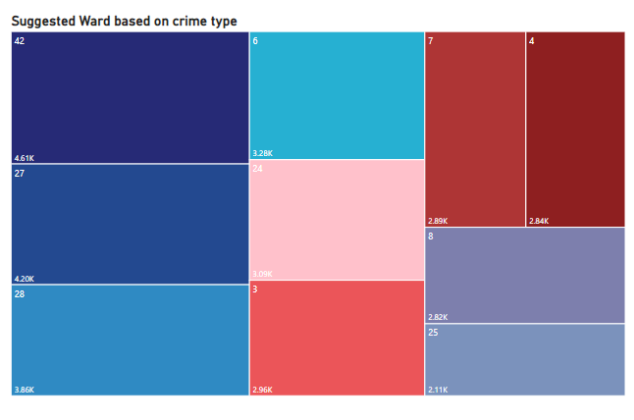

Method used: I have used tree map chart here in which rows are wards and value is count of type I applied filter on ward section and selected top 10 values

Suggested wards are: 42,27,286,24,3,7,4,8,25

Visualization method used: Tree Map, table

Location – power bi file – sheet name – suggested wards

**5.Crime Rate Trend Analysis: Monitor changes in crime rates over time to detect any discernible patterns or trends.**

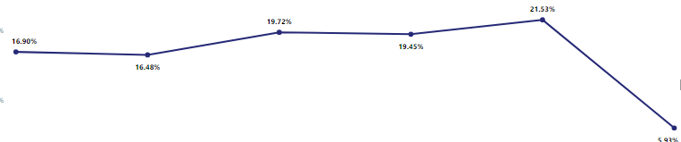



Method used: In question ask to monitor changes over time so I have used line chart here in which x axis is month and y axis is count of type

Visualization method used: Line Chart

Location – power bi file – sheet name – trend analysis

**6.As per the previous reports, most of the domestic crimes do not result in arrest due to public hesitation and family pressure, is this trend also visible in our data?**

1. **Analysis: Factors Affecting Arrests:**
   * Investigate whether public hesitation and family pressure are mentioned or documented as factors affecting the arrest rates for domestic crimes.
   * Check police reports, witness statements, or any relevant data sources.
2. **Interviews or Surveys:**
   * Consider conducting interviews or surveys with law enforcement, victims, or community members to gather insights into public hesitation and family pressure impacting arrests

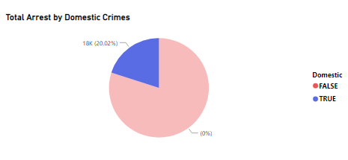

Method used: I have used pie chart for this particular question in which legends are domestic and values are count of arrest. Comparing domestic arrests and other arrests, results of domestic arrest only low

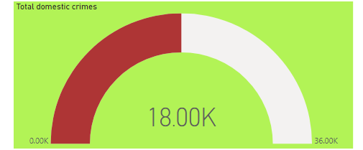

Total arrest by domestic crimes: 18.00K

Visualization method used: Pie chart, Card

Location: power bi file - sheet name -Domestic crime proportion analysis

**7.Could you generate a visual representation that emphasizes the frequently occurring terms within the "Description" column?**

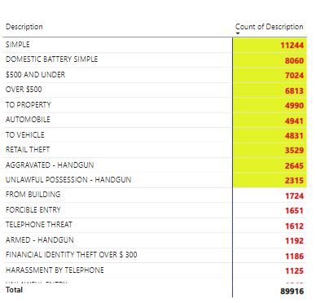

Method used: I have used funnel chart here in which category is description and value is count of description to find the frequently occurring terms so I applied filter for description section and selected more than 2000 times

Frequently occurring terms:

* Simple
* Domestic Battery Simple
* $500 and Under
* Over $500
* To Property
* Automobile
* Vehicle
* Retail theft

Visualization method used: Funnel chart

Location – power bi file- sheet name – frequently occurring terms

**8.Are there any particular regions as per the data where the number of domestic crimes reported is very high?**

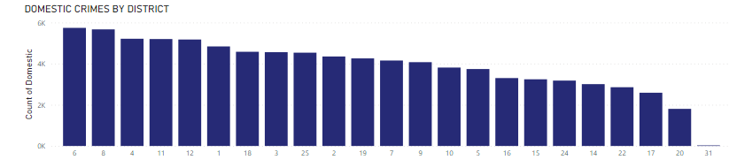

Method used: I have used stacked column chart in which x axis is District and y axis is count of domestic after creating the chart I created a table and sort by count of domestic in descending order.

Top 5 Districts with most domestic criminal activity: 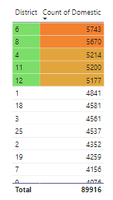

Visualization method used: Stacked bar Chart

Location power bi file – sheet name-Domestic crimes vs regions

**9.Is the solving time of cases also dependent upon type and locality of crime?**

Yes, the solving time of criminal cases can be influenced by both the type of crime and the locality in which the crime occurs. Various factors contribute to the variation in case-solving times, and understanding these dynamics is crucial for law enforcement agencies to allocate resources effectively and enhance investigative processes.

Visualization method used: Stacked bar chart

Location – power bi file – sheet name – Solving case by type and locality

